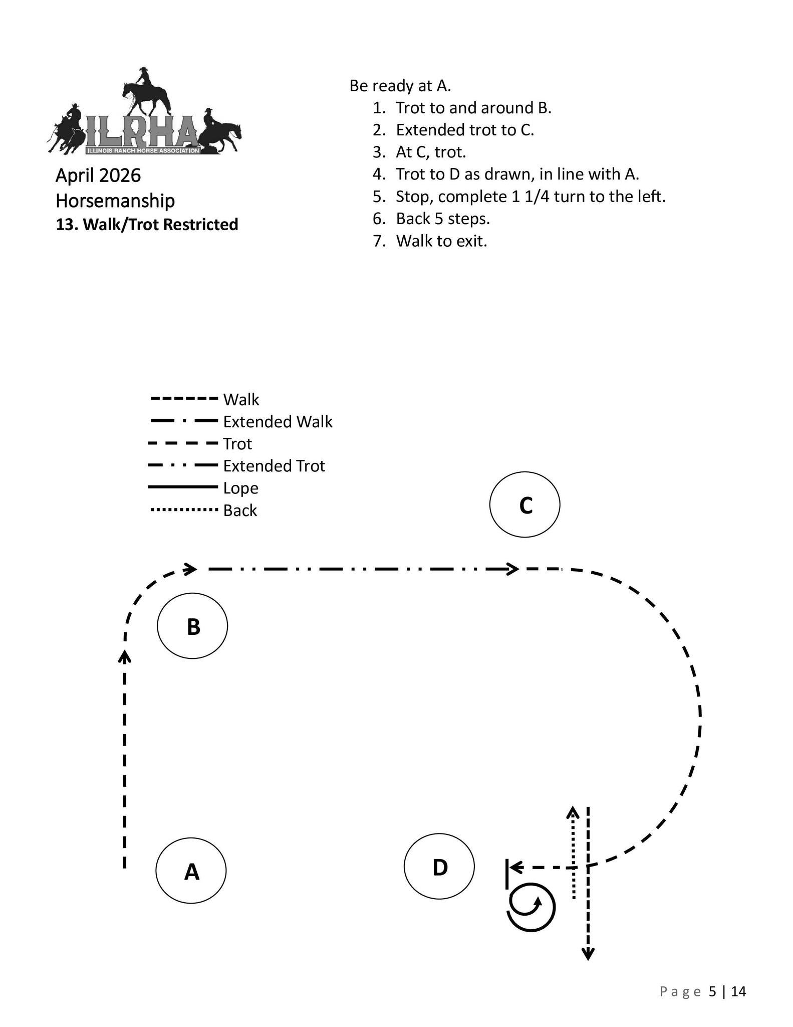
Horsemanship Walk/Trot
Classes 32 & 33

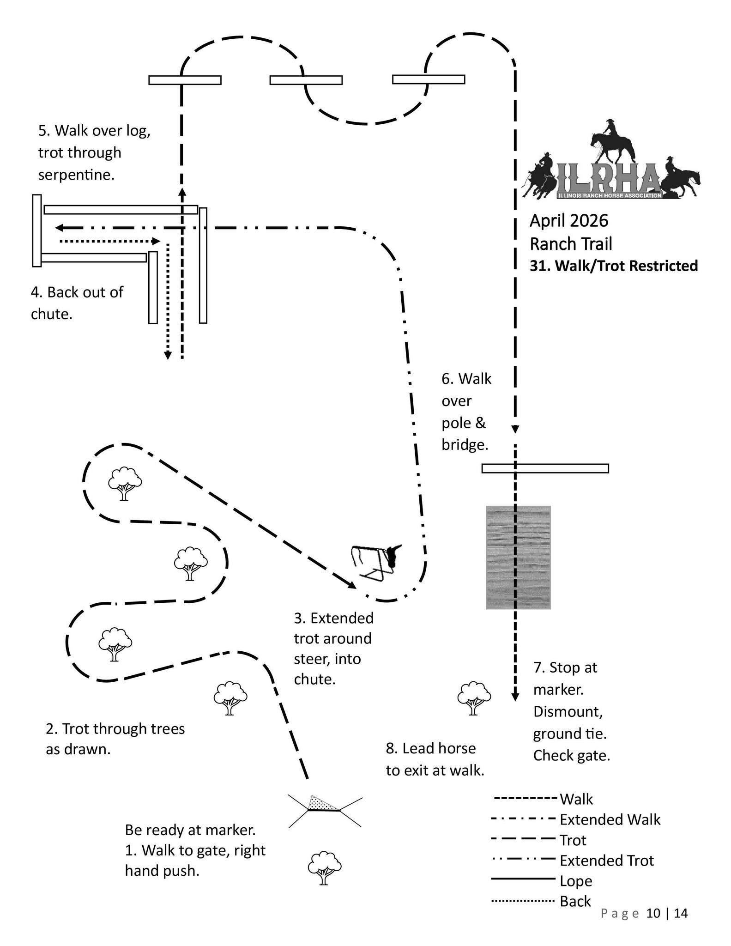
Trail – Walk/Trot
Classes 14 & 15

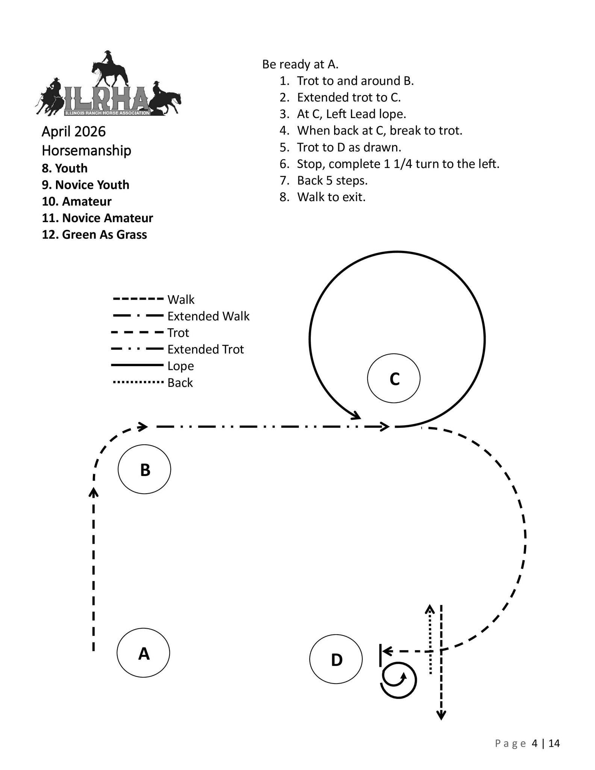
Horsemanship
Classes
34-37

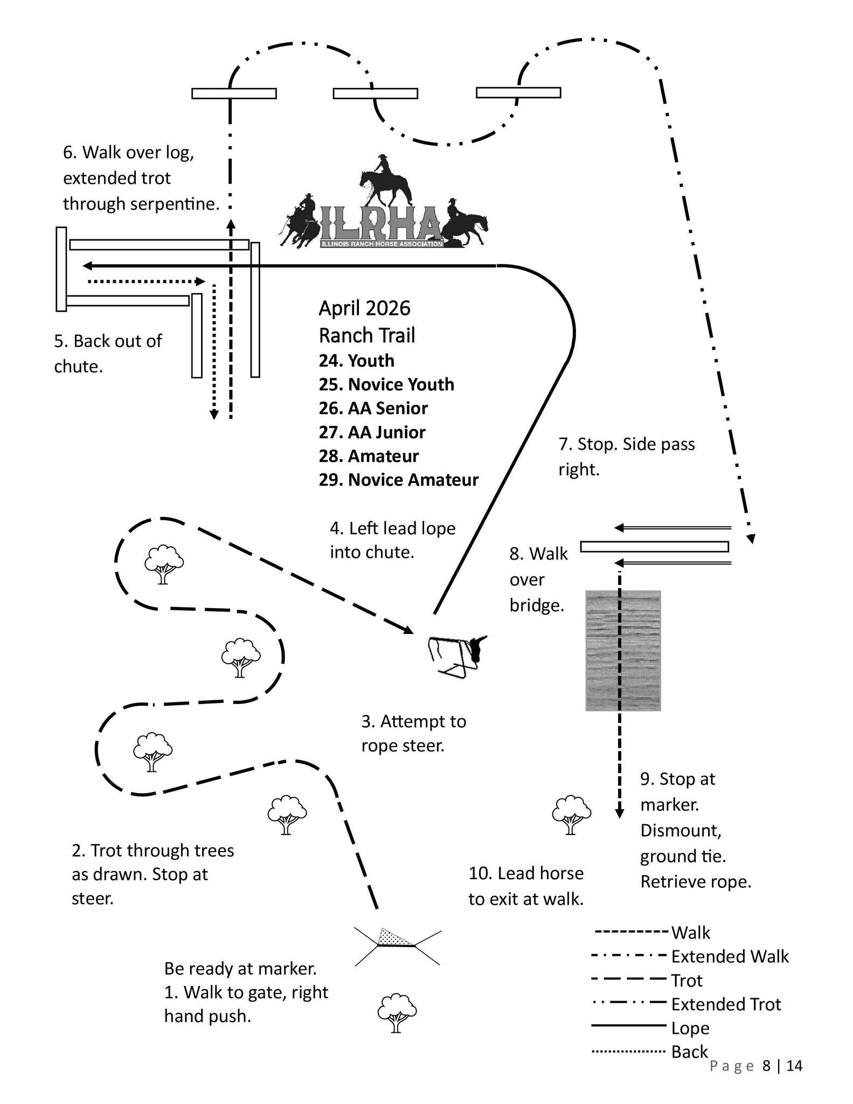
Trail -Classes 16-19

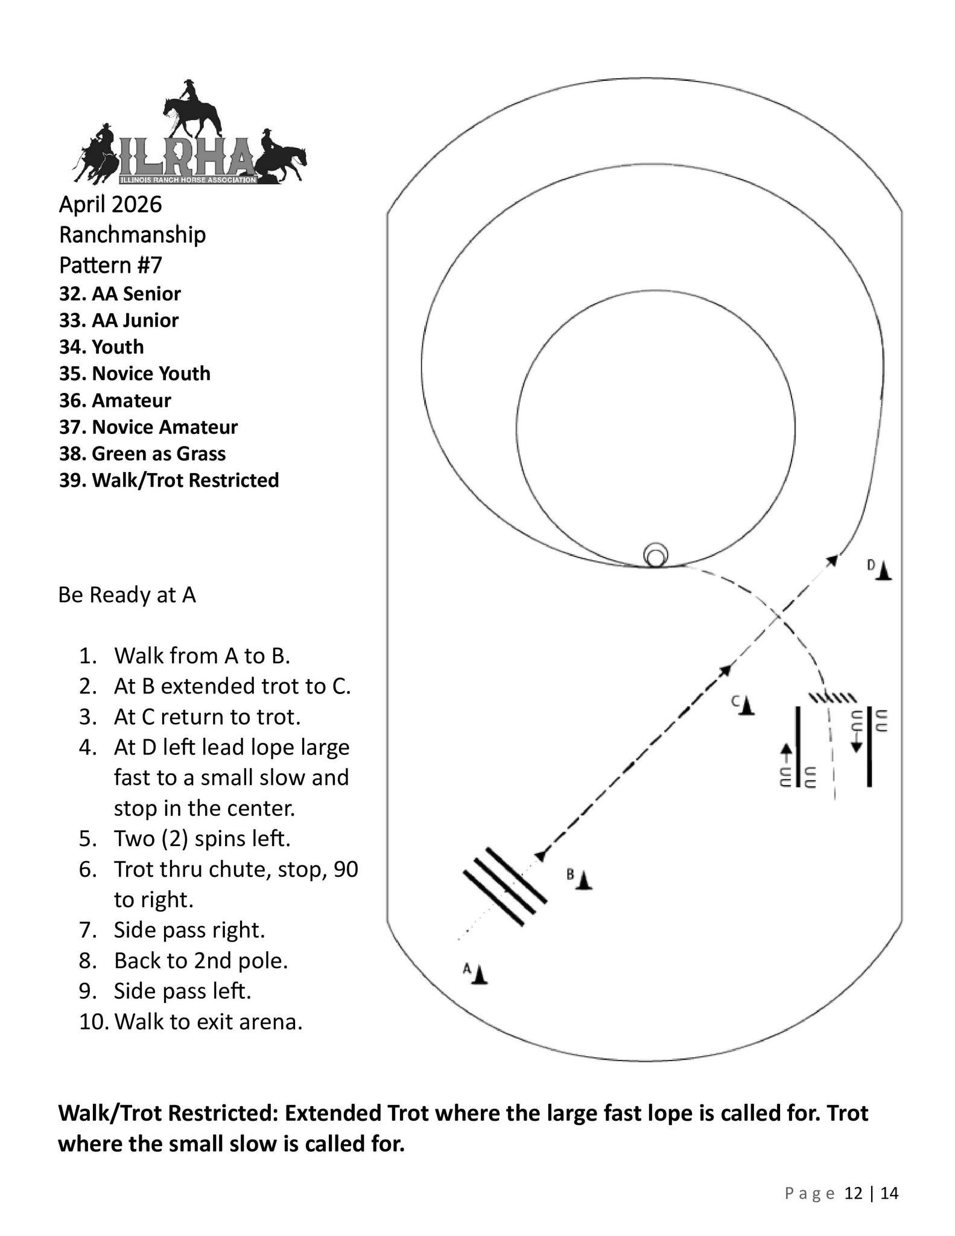
Ranchmanship
Classes 26-31
Walk/Trot – Extended Trot large circle, regular trot small circle

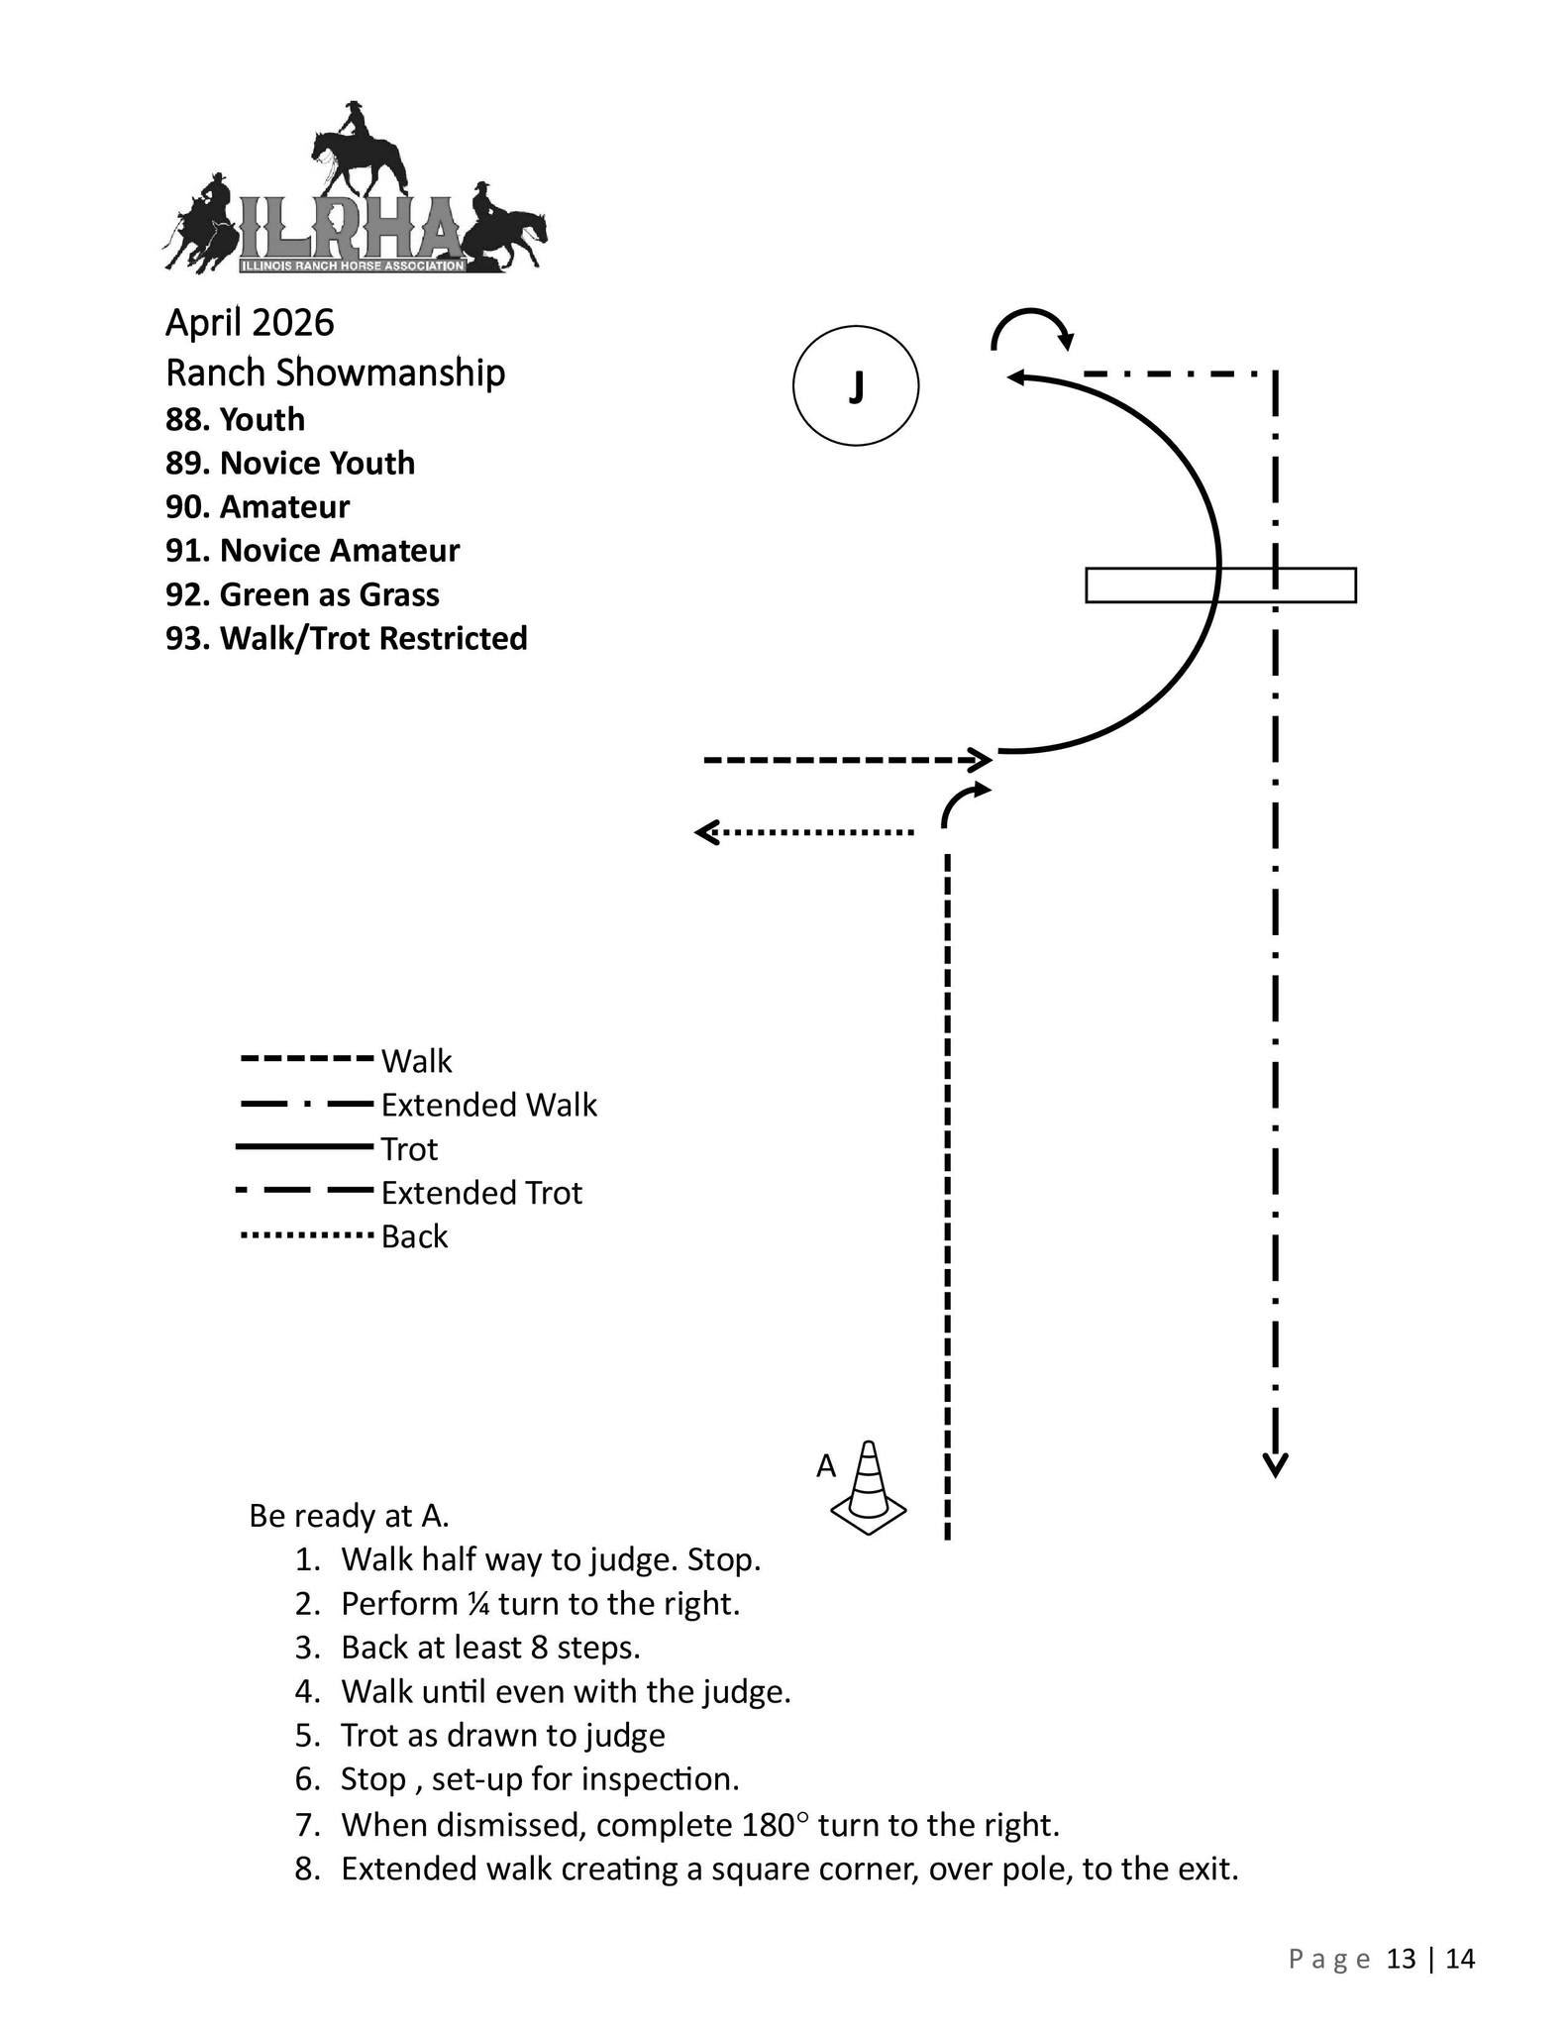
Showmanship Classes
5 - 11

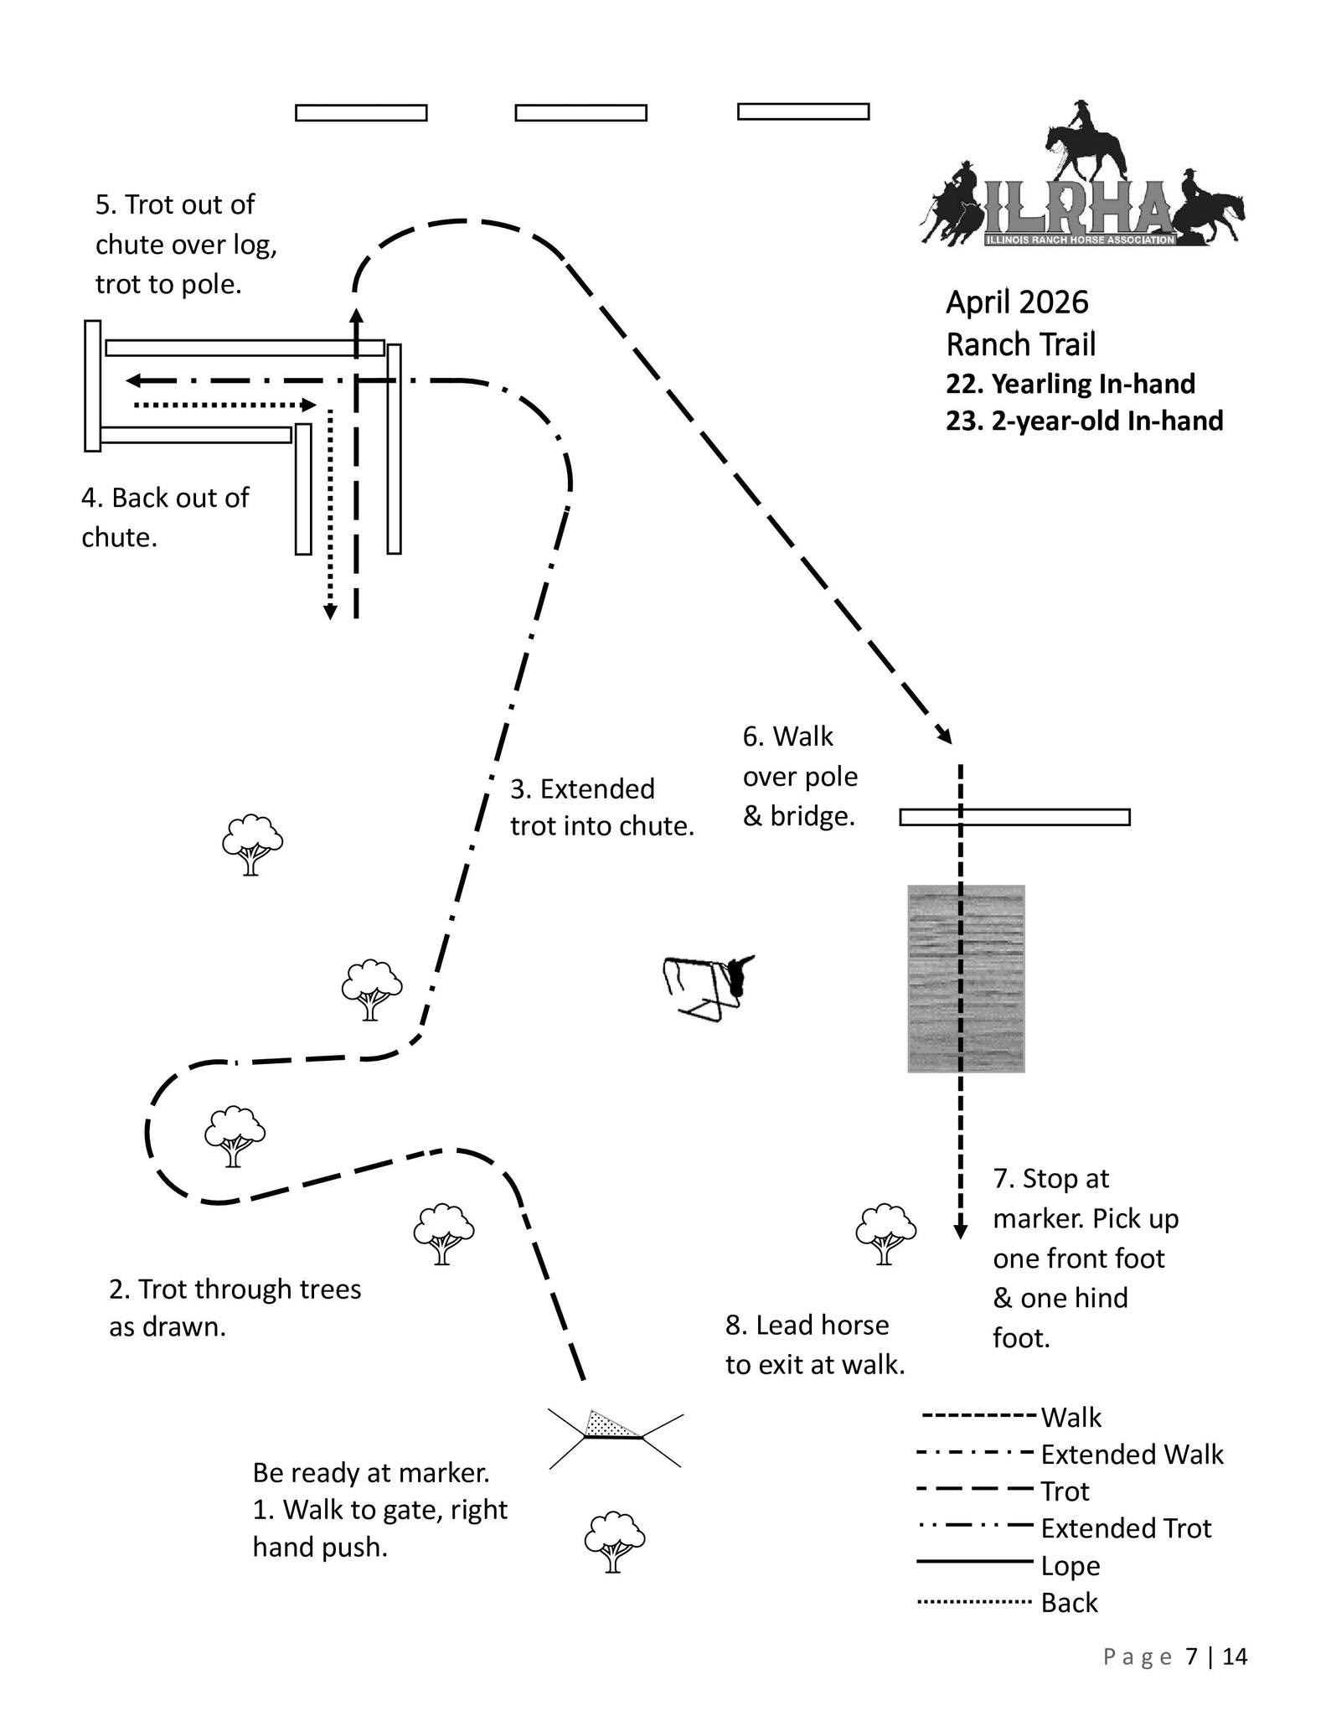
Trail – In Hand
Class 13

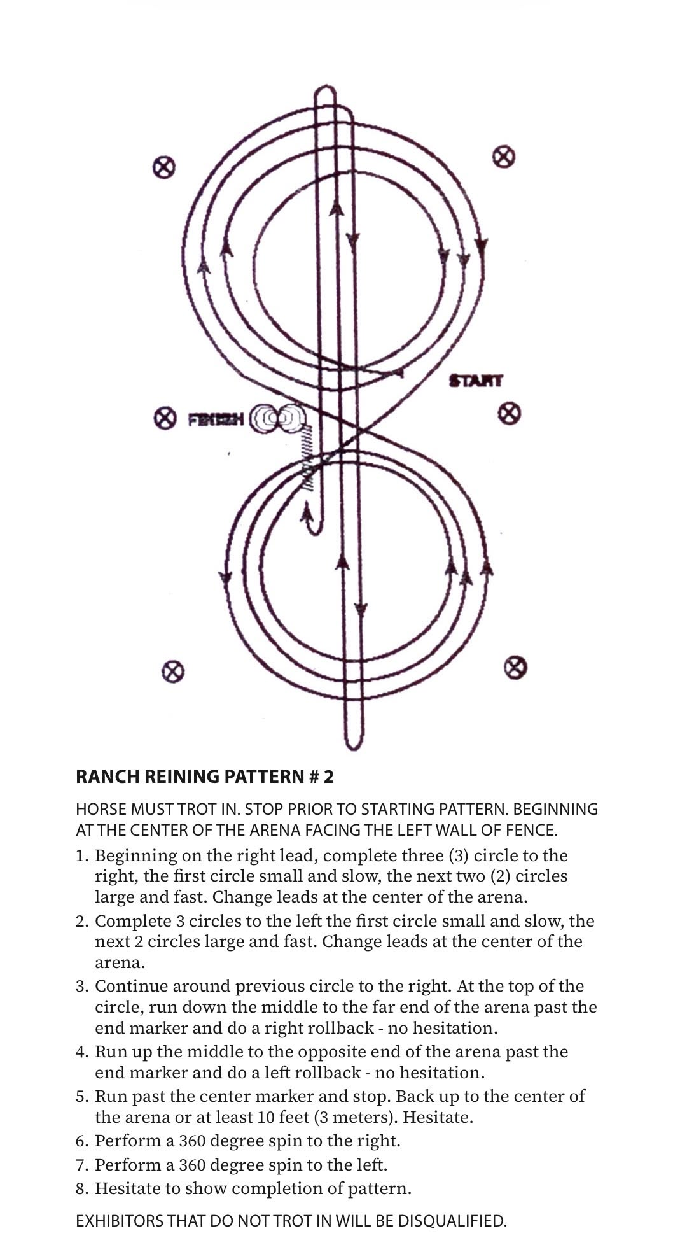
Reining – Classes 38-41

